FIRE RISK ASSESSMENT
Tree Top Catering
BURGER AND FRIES
TRAILER 2 (old burger)

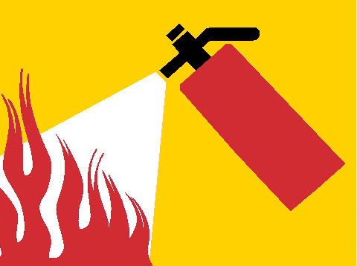

PGM Fire Safety

