FIRE RISK ASSESSMENT
Tree Top Catering
CHIPPER 3

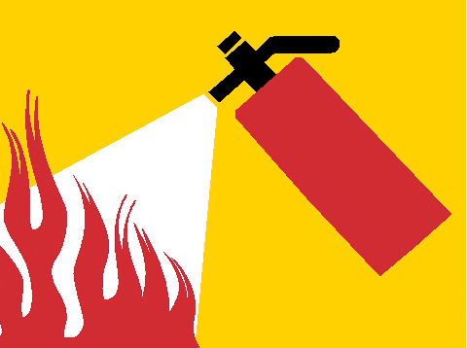

PGM Fire Safety

