FIRE RISK ASSESSMENT
Tree Top Catering
BURGER AND FRIES
TRAILER 5 red

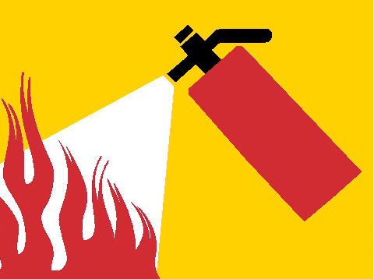

PGM Fire Safety

